Group Report

1. Together the team have decided to assign each member with a primary role and a secondary role. The roles that where assigned are seen as follows:

| **Team Member** | **Responsibility** |
| --- | --- |
| Michael Anderson | Documentation and code assistance |
| Zacari Nicholls | Code creation and documentation assistance |

As a team the group agree to ensure that quick communication will be adhered to, with no responses to take greater then 24 hours unless otherwise agreed upon.

1. The project is to develop a website that allows users to browse and submit recipes into a database. This is to allow users to have a personalised database of their favourite recipes; as well as access to an entire database of other recipes that have been added to search through.

Our initial prototype captured everything we wanted to develop in a high-fidelity model. It was completed on Figma and looked like the image in figure 1. In figure 2 you can see a closer image of a single page.

Figure - Figma prototype

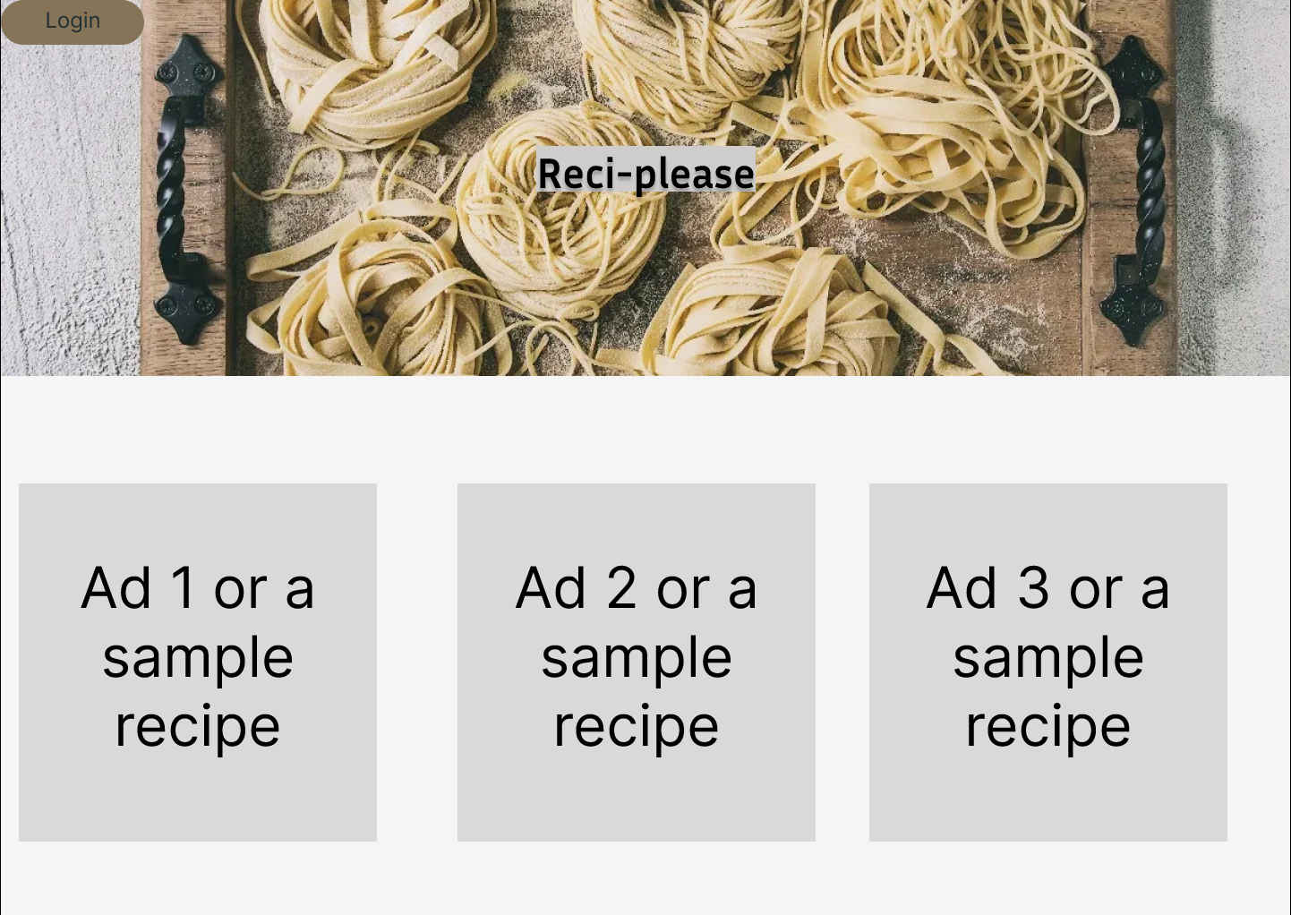

Figure - Figma prototype (Homepage)

After we compiled our prototype and was content with the layout; the way the pages interacted and how to flow of the website felt we provided the URL to the class in order to obtain user feedback. Due to the size of the feedback format I have provided the feedback received as Annex A at the end of this report. As stated in that annex – this feedback was crucial in our developmental process and benefitted our team greatly in allowing for improved quality of life on the website, as well as changing the colour palette to be more pleasing, or changing how the text and images interact.

1. The final version of the application moved into a muted palette for the colour scheme. In our opinion the greys and muted colours fit well together to give a nice warm, welcoming feel to the website – which is exactly what we desire for a family style recipe database website. These colours can be seen in Figure 3 which can also be compared to figure 2 to see how we modified the end product from the Figma prototype.

Due to the lack of back end (Which will be completed in the next assignment) some of the example pages that can be seen will have a bit of information lacking in it – once the backend has been created and a database is provided then these pages will be modified and tested with relevant information. However, for now, we have provided dummy text such as fake recipes; and placeholder welcome messages – as seen in fire 4 – user homepage.

Figure - Final homepage

Figure - User homepage

1. The file structure and associated coding has been completed with a minimalistic and obvious manner in mind. All pages are labelled to be exactly what they do; the coding flows in a self explanatory manner and comments have been added where appropriate. Both images used are clearly labelled for ease of use.

In terms of how we coded the pages – we opted to go with the style of using percentage base for the majority of styling options in order to allow for a fluid design. This meant that depending on the users screen size the layout of the page will *mostly* remain the same. Due to both members of the team having different screen sized laptops we were able to test this quite easily.

In terms of version control, due to the small nature of this project, and team, as well as the team members closeness on a daily basis, we decided to opt with conducive operations of the code. This meant that our clear and open communication was utilised to ensure that version control was maintained without any simultaneous work on similar tasks. We split our roles and ensured that when members worked on aspects of the website then the alternative member was aware and not causing any conflicts. Once we had finalised our website we uploaded the documents to a file sharing website (GitHub) in order to easily pass the information onto the assessors. Due to the small size of both the work and the project team we where able to complete the website in a short timeframe which required minimal version control.

We did not realise that GitHub was the primary method of version control in accordance with the rubric until after we had finalised the website; with only minor amendments to the code being required through it.

1. Addressing Nielsen's Heuristics or Other Design Principles [Insert a brief description of how your application addressed Nielsen's heuristics or other design principles here. This should explain how your application was designed with user experience in mind and how it adhered to established design principles.]

The primary method of design principle utilised by our team was Nielsen’s Heuristics in conjunction with a stepped process that involved with the following:

* 1. Identify the main goal
     + In this instance – the main goal of our website was a user friendly and welcoming database of recipes for future reference and with a search functionality.
  2. Consider the target audience
     + Our primary audience for this website was people interested in storing their family, or favourite, recipes in a database for sharing and referencing.
     + This meant that we didn’t want anything overly complex – as the demographic we are aiming at may not be the most technologically advanced people.
  3. Use Nielsen’s Heuristics to evaluate the website
     + In the interest of space I will not cover all ten of the heuristics; these are captured in Annex A where the user feedback is provided by other students.
  4. As a team we then read the feedback provided and adjusted the website accordingly during the previous step. Once this was done we tested it ourselves for any observed functionality or quality of life concerns that arose from our amendments.
  5. Repeated step 3s and 4 in order to evaluate our new product
     + Step 5 was conducted informally with friends from class and was not captured

In conclusion our team spent the initial phase of this project conducted research and development on the website; ascertaining how they want the website to look and function on a holistic level. Once that was determined we then moved into the production phase where we developed a prototype of how we wanted the website to look according to our vision.

After we had a prototype we sent that out to our student cohort in order to obtain feedback on it. The use of Nielsen’s Heuristics helped guide the feedback we desired and allowed for an easy understanding of any shortfalls and the ability to quickly adapt the website to accommodate this feedback. We then conducted a loop of review and adjustment to provide a product that met the visual desires of what both our team and the users wanted.

Lastly, we understood that at this point in time our project has no backend. Therefore we are ready to adjust the frontend in accordance to how it appears once we have a database with recipes within it – this has involved discussion and a rough plan to advance during the next phase.

References

All references for this report and development process where obtained as course material.

**Annex A**

**User feedback**

All user feedback provided to the group on the forums has been captured in this document. Figures 1 through 4 are screen captures of what our colleagues have written, and discussed, with us. This feedback was crucial in our development of the website and, as you can see, was utilised to adapt changes to our development process in order to finalise our product.

*Figure 1 – Diego Disley feedback*

*Figure 2 – Mitchell Torrisi feedback*

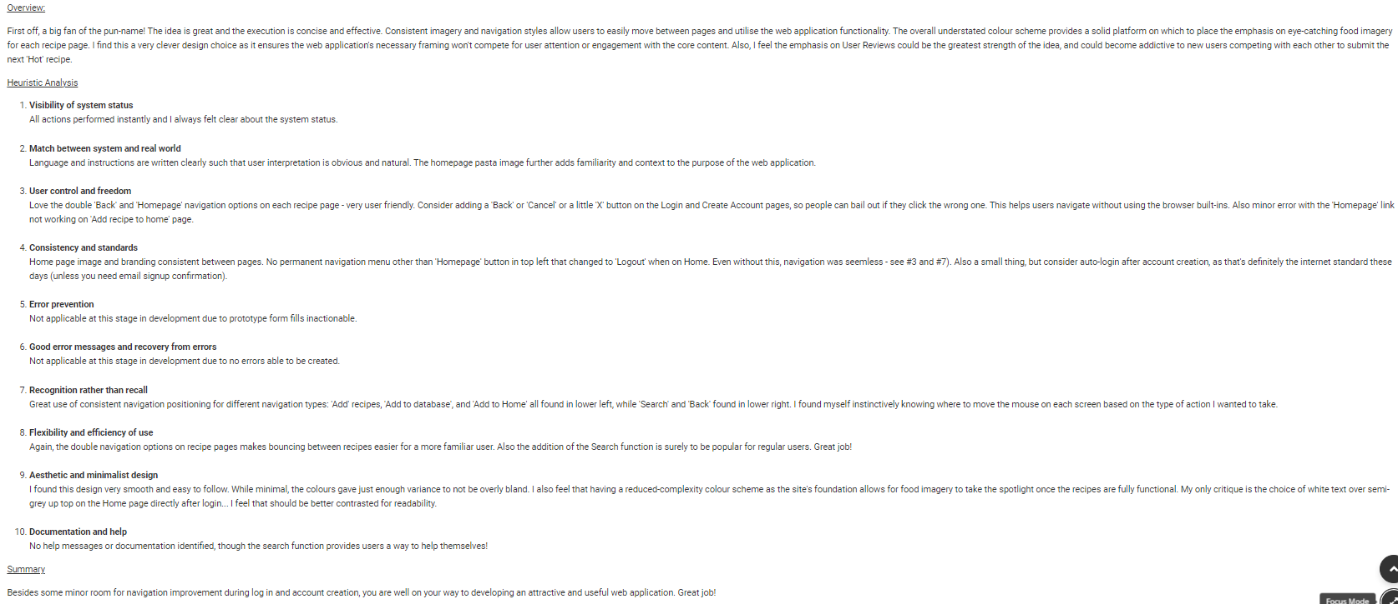

*Figure 3 – Kade Price feedback*

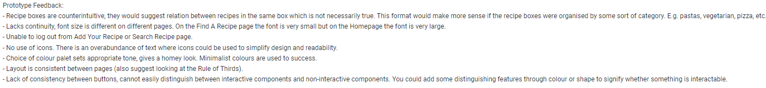

*Figure 4 – Tristan Kelly feedback*